TMP Site Live

Notifications

* Listed a product => Done
* Account Signup => Done
* Become a seller confirmation => Done
* Product sold => Done
* Order Confirmation => Done
* Shipping label

**Sign up**

* When sign up to account, authentication link needs to be sent to email to confirm their account => Done
* When creating account, can it say a message “Please check your emails to activate your account => Done
* When creating an account it should log you in once done (can we add an email checker to ensure it’s a real email?)

**Homepage**

* Can you make the video section a little bit bigger (1080x1980) as you can see the black line underneath



* Can the video be better quality

**Dashboard**

* Edit a picture doesn’t work

**Account Details**

* When creating an account, you sign up with a phone number, but when you go into account details the phone number box is empty
* I have checked about point, The phone number is showing on user account.

**Bank Info**

* When the 16 digit code is saved can the first 12 digits be blanked out by black markers
* On the 16 digit card number, can you make it so that only 16 numbers can be entered (No more than 16 & shows an error if 16 digits aren’t entered)
* Expiry year to only be 2 digits
* Can we add a 3D Secure Authenticator to ensure the card is authentic
* We need to make it so that before a Seller can list a product **THEY MUST** insert “Sellers Details” and “Payout Email”
* Sellers Details – We need to make a note to tell Sellers that a Credit Card must be inserted here (Can we use a 3D secure authenticator to check if the card is a credit card?)

**Verify & Start Selling**

* Needs to say “Become a seller” => Done

**My Listings**

* Can the size and font be the same => Done
* In Status, can it say “Live” instead of “Publish” => Done

**My Subscription**

* If there are no subscriptions under “My Subscription” can it say “None” => Done
* When you click “Verify” it doesn’t bring you the “become a vendor” section => Done

**Orders**

* Can you remove this



* When you click “Details”

Can it say “Order Details” (The s is missing)

Order Date Time to be renamed to “Order date / Time – XX.XX.XXXX / XX:XX”

Can you remove the “Order Reference” part, please replace the order”#9” with the TMP order reference (Keep in bold (It should say “Order **#TMP-XXXXXX** is currently **XXXXXX”**

Remove “Payment type” (Stripe payment card)

Put £ signs infront of the price amounts

Remove this whole section (The whole point of the site is animosity)

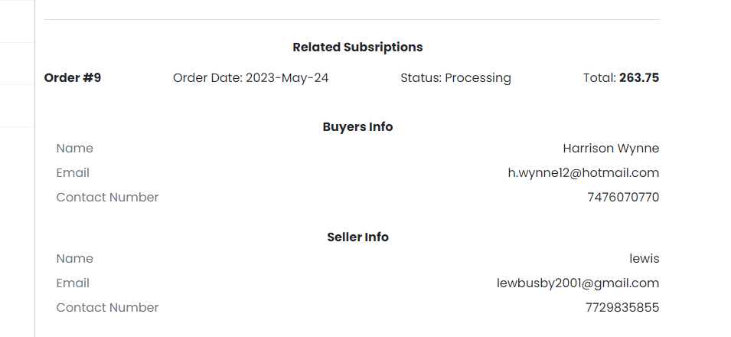

This section is wrong

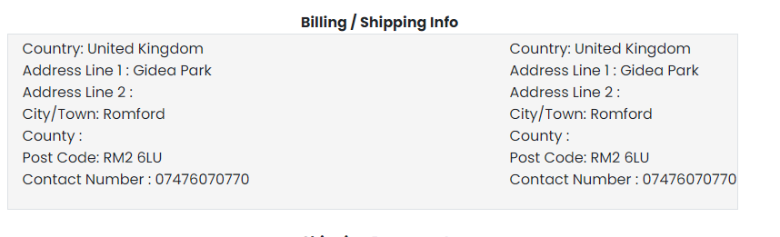

This section doesn’t need to be here for the User who **Bought** the item 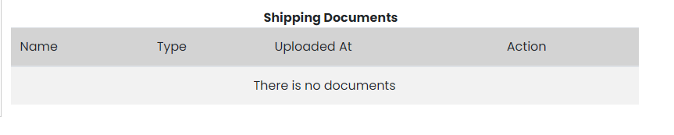

**Sell a product**

* When seller enters the sku, can it bring up the product name underneath

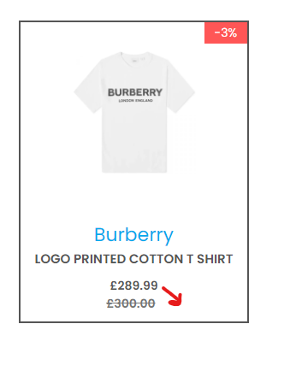

* Can we change “Pre-Owned” to “Pre-Loved”
* Can we add a Heart next to Add to Cart in both New and Pre-Loved, where users can add that specific product to their Wishlist

**Product**

* When there are multiple listings from sellers on a product can you only put the lowest price in the box

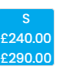

**Shopping bag**

* Can this section be at the bottom of the page

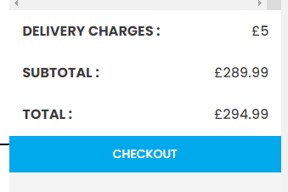 (Please also remove “Delivery Charges” and “Total” from this section (Keep “Subtotal”) This will be shown when clicked “Checkout”

* When you cart a sellers product, if new can you use the Admin Picture, if Pre-Loved can you use their first Picture

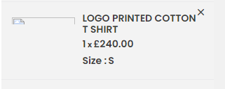

**Checkout**

* How is the processing fee calculated? It should take the figure from the Admin Portal > Settings > Commission Settings (Which is currently showing 10%)

**Admin**

**Users**

* Seller requests doesn’t work (When user tries to verify their account, it doesn’t get sent to this part)

**Products**

Sellers Products

* When you click “View” can there be another bar saying “New / Pre-Loved” and inside the box it will either say “New” or “Pre-Loved” depending what the seller has listed it as
* When you click “Update” can it take you to the page before
* Can selling price has 2dp